**CMPSC 121** Name _____________________________

**Lab Experiment 09**

**Purpose:**

This experiment is designed to develop confidence with functions.

**Readings:**

This experiment focuses upon the material covered up through chapter 5 of our text.

**Instructions:**

Write a program that asks a user to enter a date in month day year format   
(for example 10 12 2016) and displays the day of the week for that date, in this case, Wednesday.

Be sure to validate month and day to be sure they are in range. To validate 2/29/yyyy, you will have to call the **isLeapyear** function.

## The algorithm discussed here is based upon the article at <http://en.wikipedia.org/wiki/Calculating_the_day_of_the_week> under the heading: *A tabular method to calculate the day of the week*

You will require several functions:

**bool isLeapYear(int year);**

This function will return true if the year passed is a leap year and false if not. The pseudocode to determine if a given year is a leap year is:

leapYear = ((year evenly divisible by 400) or ( year evenly divisible by 4 and year NOT evenly divisible by 100))

**int getCenturyValue(int year);**

This function should take the first two digits of the year (ie the century), divide by 4 and save the remainder. Subtract the remainder from 3, multiply the result by 2 and return that value. For example the year 2013 becomes (20/4) = 5, remainder 0. 3 – 0 = 3 return 3 * 2 = 6. Hint, to get the century divide by 100.

**int getYearValue(int year);**

This function computes a value based on the years since the beginning of the century. First, extract the last two digits of the year (year%100), in this case 13. Next, factor in leap years. Divide the last two digits by 4 and add that back to the result and return that. Eg (13/4) = 3. 3 + 13 = 16.

**int getMonthValue(int month, int year);**

This function should return a value based on the table below and will require calling the **isLeapYear** function.

|  |  |  |
| --- | --- | --- |
| Month | Return (if not leap year) | Return (if leap year) |
| 1 | 0 | 6 |
| 2 | 3 | 2 |
| 3 | 3 | 3 |
| 4 | 6 | 6 |
| 5 | 1 | 1 |
| 6 | 4 | 4 |
| 7 | 6 | 6 |
| 8 | 2 | 2 |
| 9 | 5 | 5 |
| 10 | 0 | 0 |
| 11 | 3 | 3 |
| 12 | 5 | 5 |

Finally, to compute the day of the week, add together the day and the values returned by getMonthValue, getyearValue, and getCenturyValue. Divide that sum modulo by 7.   
0 indicates Sunday, 1 Monday, 2 Tuesday, etc.

Sample run:  
  
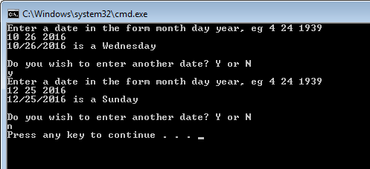

**Experimenter** **Notes:**

Write a paragraph in acceptable, well-formed English sentences. The paragraph should detail the information that you have gleaned from this experiment. Be sure to include comments on what happened that was unexpected.

**Deliverables:**

See instructions on Canvas